SUSTAINING GRACE
A newsletter from Andy & Jessie Clark
Missionaries in Autlán, Mexico

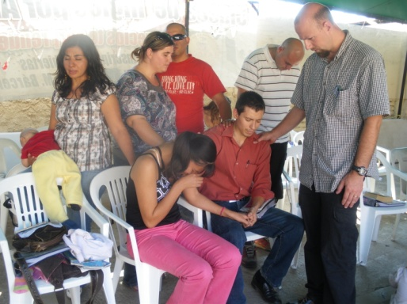
Sending Out!
We met Norma and Carlos Rosales a year and a half ago, just a few months after the start of La Roca Church plant. They had just become believers and were searching for fellowship when they wandered into our Church. The first time I (Jessie) met them, Norma had just had a horrible miscarriage and we went to visit them in their home. It was the first time I had been confronted with the poverty of Autlán. They lived in a small two room dirt floor house with no security and plastic covering the windows. I remember sitting on the edge of their bed and realizing it was a wood base covered with a blanket. Since I first met them I have watched a faith that surpasses all circumstances grow within them. I have watched as both sides of their family reject them for their faith and I have watched them boldly proclaim the word of God. A few months ago Carlos found out that Tecate Mission (our sending organization) has a Bible institute and he and his wife felt the Lord directing them to go. After they were accepted I watched in amazement as they sold all their positions just to have the finances to make the journey! In late December our little Church sent them, along with their two kids, off to Bible school. They are enrolled in the four year program as Carlos has a desire to become a Pastor. We will dearly miss them but are overjoyed to send them out. Please pray for this wonderful family.
Big Changes

John and Elizabeth, our teammates here in Autlán have moved-on to live in Alaska to care for their new son Daniel who has profound hearing loss. Daniel was unable to get the medical care and speech therapy he needed here in Mexico. It is a very big change for us because we have added all their ministry responsibilities to our plate. One of the biggest changes that has taken place is that I (Andy) have taken on the pastoral position of our church plant. At first we were not sure we could sustain all of the ministries but through prayer we felt the Lord saying, "My grace will be sufficient". This is a very challenging time for us right now and we thank you for keeping it in your prayers with us.
Galatians 6:9-10 "And let us not grow weary while doing good, for in due season we shall reap if we do not lose heart. Therefore as we have opportunity, let us do good to all especially to those who are of the household of faith."
Prayer needs:
- Norma and Carlos Rosales who are going to bible school.
- For the changes we are facing with John and Elizabeth leaving the mission field.
- Jessie’s health during her pregnancy.
- Your continued prayer for our financial support.

In His Grip,

andyjessiec@yahoo.com / www.sustaining-grace.blogspot.com / (651) 472-9214

