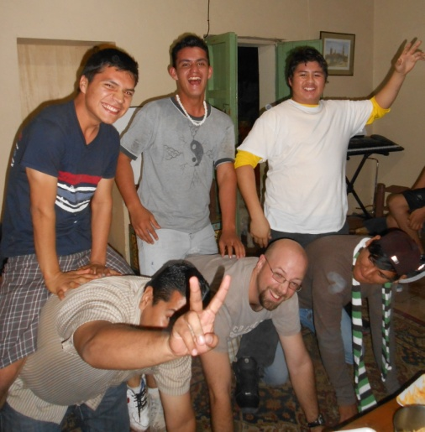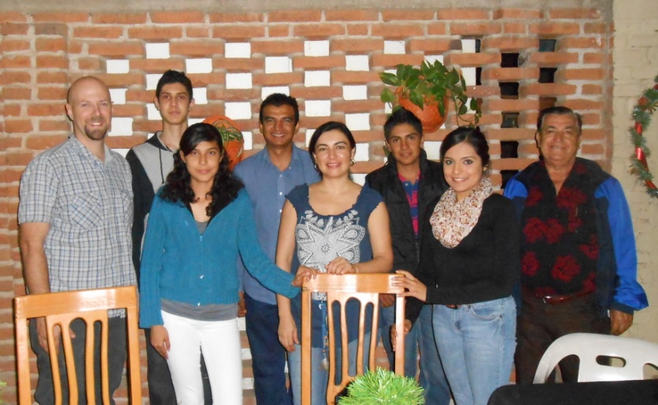
A bunch of the guys who are attending the men’s bible study My English class during our Christmas party

English Classes
We are currently in our second semester of classes. To share with you one aspect of the class, at the beginning of every class we read a text from scripture. After picking out words that they have learned, and seeing if they understand what it means, we will read it Spanish. It is often times the first time they have ever read the bible. We plant one seed at a time.

Women’s bible study
Jessie is currently doing a women’s bible study with some of the ladies of the church. They eagerly study the truth in Proverbs. Soon they will be transitioning into a Beth Moore study on “Knowing God”.

Support information:
Tecate Mission International
P.O. Box 1000
Tecate, CA 91980
Please indicate on a separate piece of paper that the donation is for the Clark family.

Check out our website for more updates at www.sustaininggrace.com
In Him,

Andy and Jessie

