knew it was time to address their living situation. It often is hard to address this topic because many couples live together because of finances. This was very much the case with Alonzo and Maria.
We felt the presence of God during that conversation and I felt His wisdom in us as we spoke to them. We sat around our kitchen table for over 6 hours pouring over scripture with them and answering tough questions. The discovery that we made in the end, that we were not expecting, was that Alonzo was desperate to know Jesus and follow Him. As soon as he was able, he moved out of their home and committed to stay pure until marriage. This was not an easy choice for them, as it has caused a great deal of financial problems for them, but they stay committed to following after Jesus. This is very uncharted territory for Andy and I and we ask for your prayers that the Lord would give us wisdom in dealing with them. Please pray with us for the new faith of Alonzo; that he would continue to seek Christ and His glory.

This newsletter has turned out to be rather long! I've got so much I want to write about. I promise you are almost done. :)
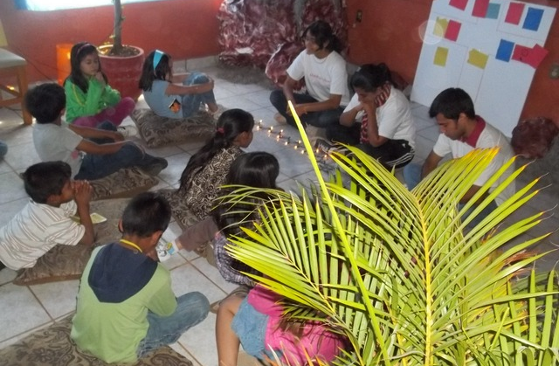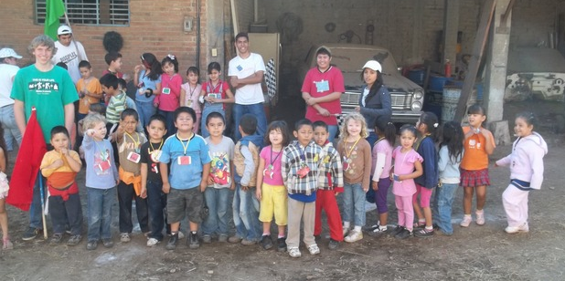
We want VBS!

We have put on a lot of programs and events over the years that we have lived in Autlán, but rarely do we get asked to put them on again! This December, back by popular demand, we are hoping to put on a Christmas VBS again. We did this last year and it was a big event with over 70 kids from around the city. Last year we focused on hiding the truth in the hearts of the kids. We wanted them to have fun, but our main goal was to plant seeds in them that by God's grace will one day grow. If the Lord allows, we will be doing this again this year. The problem we have is that last year we had the finances to do this and this year we do not. So, anyone want to help make this possible? We would need around $300 to purchase the materials, snacks, craft, decorations, etc.

Support information:
Tecate Mission International
P.O. Box 1000
Tecate, CA 91980
Please indicate on a separate piece of paper that the donation is for the Clark family.

Check out our website for more updates at www.sustaininggrace.com
In Him,

Andy and Jessie

