WE ARE ONE

After my brother’s team came down in August and did street evangelism through dramas, testimonies and music, it produced a desire in our youth to do the same. This formed a group of various young people from different churches called WE ARE ONE. We had our first event on February 15th at a park, which was a great learning experience. The group meets on a weekly basis. Our main goal is to know Jesus and to make Him known. This is the one of the first times that our youth have stepped out in their own in ministry. Although I (Andy) am supervising the group, we are allowing it to be youth led. Please pray with us, for the focus of this group, and for the outreaches they will be doing on a monthly basis. To my knowledge, this kind of ministry has never been attempted before in Autlán.

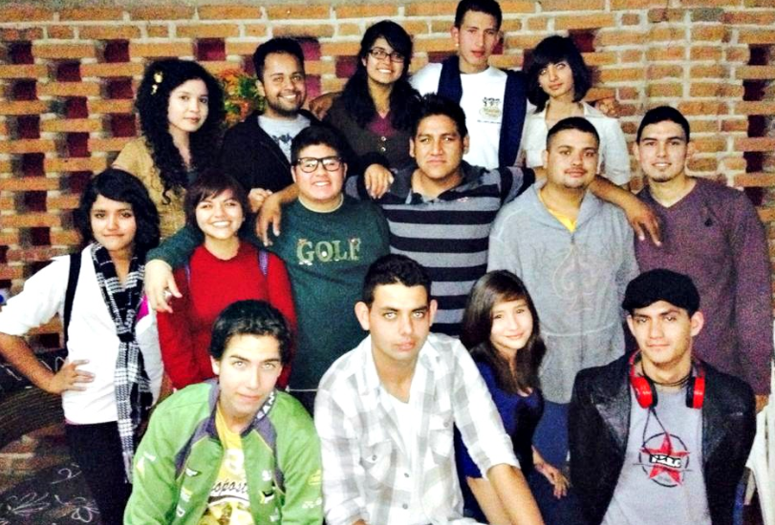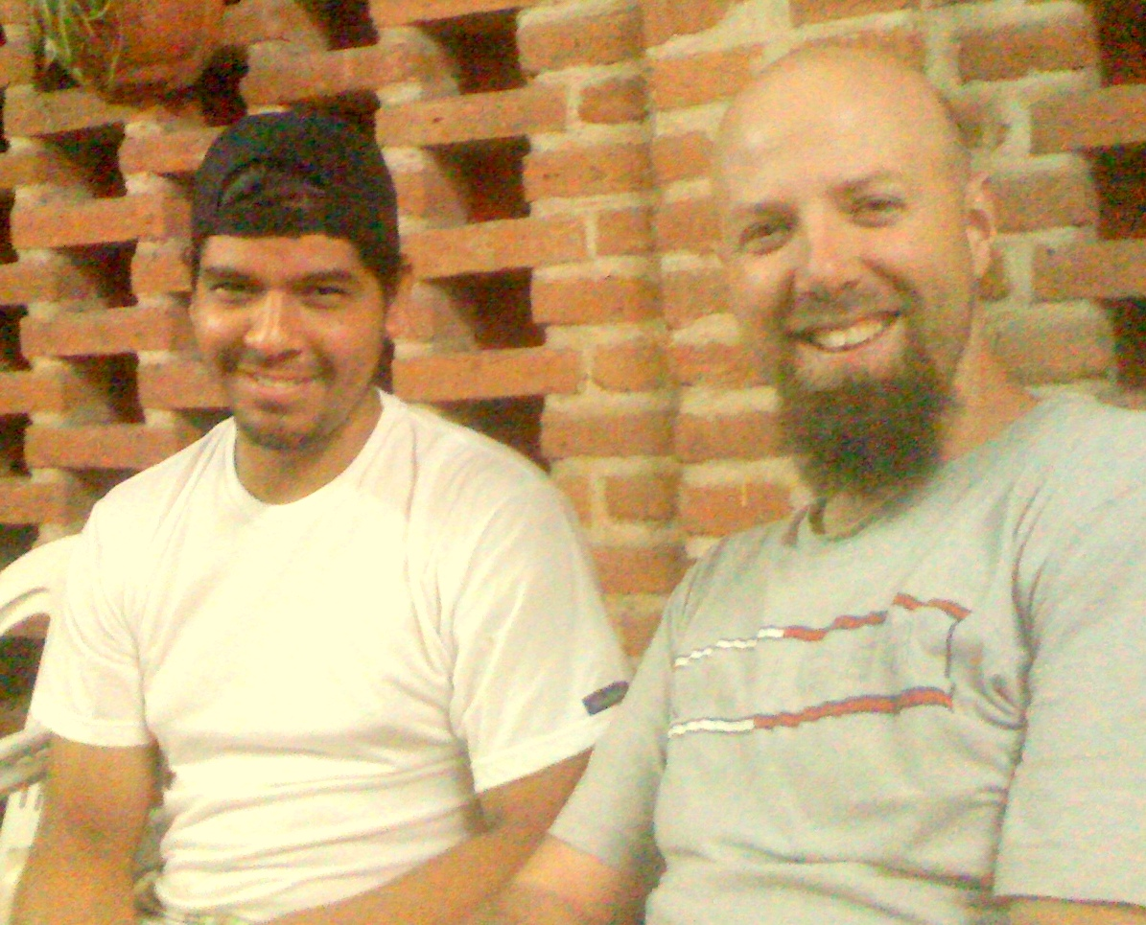

MINISTERING TO “THE CHURCHED.”

In our ministry here, we are almost always ministering and disciple people who have never cracked a Bible open or stepped into a Christian church. Often those who desire to follow Jesus have little biblical knowledge. Juan, however, is not the case. His wife, Yulie, started coming to church activities a few months back and soon after was dragging her husband, Juan, with her. At first, he was resistant and quiet. I later learned that Juan had grown up in a Baptist church and his father was a pastor. He has since rejected the church and drifted from biblical truth. He has a lot of knowledge of scripture, but has no practical application of it. Over the years you can see how he has mixed his Bible belief with worldly philosophies. I find this always to be the case when people stray away from that intimate daily relationship with Jesus. They begin to mix lies with the truth and come up with all sorts of justifications for their sin. We literally make our own religion and our own personal image of God. Juan has been a new experience for us. He and his wife are now attending every single event and meeting we have. He is very open and seems hungry for more truth. Please pray with us as we share the truth with him.

Support information:
Tecate Mission International
P.O. Box 1000
Tecate, CA 91980
Please indicate on a separate piece of paper that the donation is for the Clark family.

Check out our website for more updates at www.sustaininggrace.com
In Christ,

Andy and Jessie

