mention the travel that would be involved in it. We currently own a 1999 Ford Expedition and are looking to buy something like it. With the rough roads, massive speed bumps, and frequent traveling, this kind of vehicle works well for us.

To my shame I have worried and fretted about many things in our life in Mexico. Our Sovereign Lord has always provided and cared for us, so I will not worry and fret about such things. I do not know how long we will be without a vehicle, but I trust the Lord that He will provide at the appointed time. Please pray with us. If you would feel compelled to give toward the purchase of a new vehicle, donations can be sent to Tecate Mission International (our sending missions organization). We will update you as the funds are raised.
We trust God and believe what Paul said
"And my God shall supply all your need according to
His riches in glory by Christ Jesus."
Philippians 4:19 (NKJV

One of the few pictures of our time home in the states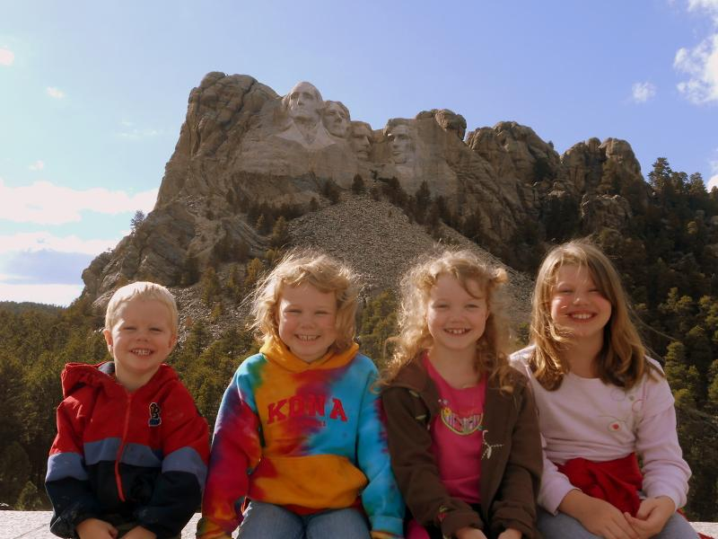

Support information:
Tecate Mission International
P.O. Box 1000
Tecate, CA 91980
Please indicate on a separate piece of paper that the donation is for the Clark family.

Check out our website for more updates at www.sustaininggrace.com
In Christ,

Andy and Jessie

